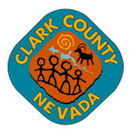

More Positions:

507769 FIRE AUTO & EQUIPMENT SPECIALIST

507771 Juvenile Detention Assistant

507773 WRD WW Collection Systems Technician I

Check out EmployNV.gov for further information.

