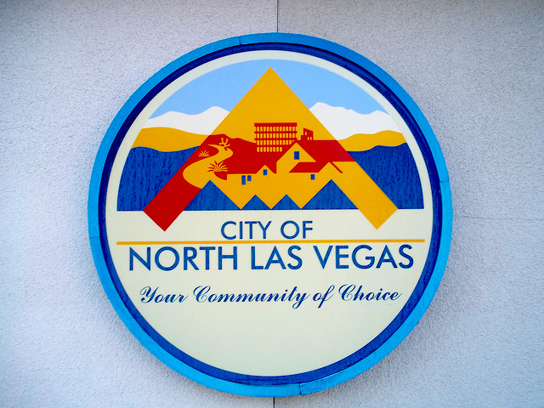
507758 Lifeguard – Various Locations
507759 Aquatics Coordinator - Various Locations

507766 Class Instructor IV – Silver Mesa Rec Center

507767 Classification Technician

507768 Inventory Control Specialist

507762 Law Enforcement Support Technician – Community Corrections Center

507765 Maintenance Helper PT/Temp

507761 Program Specialist – Temp

507764 Senior Programmer Analyst – IT

507760 Water Safety Instructor – Various Locations

Check EmployNV.gov for further information

Job Orders expire 07-2-2020 unless filled prior thereto.

